Time for another sample application. This one is built specifically to help out Vault programmers, however I suspect that people will find other uses.
In a nutshell, Vault Query lets you make direct calls to the Web Service API. The results are then displayed in a tree view, similar to the Visual Studio debugger. This is a good way to sift through complex data, such as property mappings, lifecycle states or BOM data.
Just for fun, I decided to write this in WPF and give it an awesome UI.
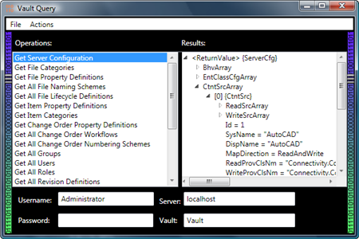
(click image for full view)
Requirements:
- To use the EXE
  - .NET 3.5
  - Vault 2011 Server (any version) installed on the network.
- To use the source code
  - Visual Studio 2010
  - Expression Blend 3 or 4
Click here to download the application
Click here to download the source code
To use:
This is a stand-alone EXE, so you don't need the Vault Client installed.
On the left you have a list of operations. Each operation represents a single web service call with specific input parameters. Double click on the operation and it runs. The output is presented in the right pane.
I set up a bunch of operations out-of-the-box, but you can add your own. You can either use the "Add Actions" command or edit the Operations.xml file. In theory, any API call can be made into an operation. However the UI is picky about what input types it supports. You may need to edit Operations.xml for many cases.
